|  |
| --- |
| **Neha Malhotra** **R.L. Chemistry Classes M: 9253556635**  **Class : XII**  **“HUMAN REPRODUCTION”** |

**Level – 1**

**(Based on Male Reproductive System)**

1. Testes in human male lie :

|  |  |
| --- | --- |
| a) in the abdominal cavity | b) outside the abdominal cavity in scrotum |
| c) in the scrotum in abdominal cavity | d) lie freely outside the abdominal cavity |

1. Sertoli cells are present in :

|  |  |  |  |
| --- | --- | --- | --- |
| a) seminiferous tubules | b) ovary | c) pancreas | d) corpus luteum |

1. Leydig’s cells are present in the :
2. connective tissue present between seminiferous tubules
3. lumen of seminiferous tubules
4. germinal epithelium along with spermatogenic cells
5. Stroma of ovary
6. Androgen binding protein (ABP) is secreted by :

|  |  |  |  |
| --- | --- | --- | --- |
| a) Leydig’s cells | b) spermatogenic cells | c) sertoli cells | d) none of these |

1. Male sex hormones are secreted by :

|  |  |  |  |
| --- | --- | --- | --- |
| a) Leydig’s cells | b) sertoli cells | c) vasa efferentia | d) spermatogenic cells |

1. The transformation of spermatids into spermatozoa is termed as :

|  |  |  |  |
| --- | --- | --- | --- |
| a) spermatogenesis | b) spermatocytogenesis | c) spermiogenesis | d) spermiation |

1. Which part of spermatozoa contains hydrolytic enzymes?

|  |  |  |  |
| --- | --- | --- | --- |
| a) middle piece | b) acrosome | c) tail | d) Neck |

1. Which of the following is “immortal”?

|  |  |  |  |
| --- | --- | --- | --- |
| a) somatic cells | b) glomerular cells | c) germ cells | d) Cells of pituitary |

1. Sertoli cells are regulated by the pituitary hormone known as :

|  |  |  |  |
| --- | --- | --- | --- |
| a) LH | b) FSH | c) GH | d) Prolactin |

1. In humans, at the end of first meiotic division, the male germ cells differentiates into the :

|  |  |
| --- | --- |
| a) spermatids | b) Spermatogonia |
| c) primary spermatocytes | d) secondary spermatocytes |

1. In the male reproductive system, sperms are concentrated in the :

|  |  |  |  |
| --- | --- | --- | --- |
| a) rete testes | b) epididymis | c) vas deferens | d) seminal vesicle |

HUMAN REPRODUCTION Page No. 1

1. 2n = 16 in a primary spermatocytes which is in metaphase of the first meiotic division. What shall be the total number of chromatids in each of the secondary spermatocyte?

|  |  |  |  |
| --- | --- | --- | --- |
| a) 16 | b) 24 | c) 32 | d) 8 |

1. Seminal plasma in humans is rich in :

|  |  |
| --- | --- |
| a) Fructose , enzymes but poor in calcium | b) Fructose , calcium and certain enzymes |
| c) Fructose , calcium and no enzymes | d) Glucose , enzymes but poor in calcium |

1. The vas deferens receives duct from the seminal vesicle and opens into urethra as :

|  |  |  |  |
| --- | --- | --- | --- |
| a) epididymis | b) ejaculatory duct | c) efferent ductule | d) ureter |

1. Urethral meatus refers to the :

|  |  |
| --- | --- |
| a) urinogenital opening | b) opening of vas deferens into urethra |
| c) external opening of urinogenital duct | d) muscles surrounding the urinogenital duct |

1. The difference between spermiogenesis and spermiation is :
2. In spermiogenesis spermatid are formed , while in spermiation spermatozoa are formed.
3. In spermiogenesis spermatozoa are formed , while in spermiation spermatid are formed
4. In spermiogenesis spermatozoa from sertoli cells are released into the cavity of seminiferous tubules, while in spermiation spermatozoa are formed.
5. In spermiogenesis spermatozoa are formed , while in spermiation spermatozoa are released from sertoli cells into the cavity of seminiferous tubules
6. Which of the following is a transporting tube leading from the bladder which brings urine outside the body via penis?

|  |  |  |  |
| --- | --- | --- | --- |
| a) Ureter | b) Epididymis | c) Ejaculatory duct | d) urethra |

1. Semen is constituent of seminal plasma with ________.

|  |  |  |  |
| --- | --- | --- | --- |
| a) Ovum | b) sperm | c) zygote | d) follicle |

1. Which gland releases a small amount of fluid just prior to ejaculation to decrease acidity in the urethra caused by urine?

|  |  |  |  |
| --- | --- | --- | --- |
| a) prostrate | b) glans penis | c) seminal vesicle | d) Cowper’s gland |

1. The penis is :
2. The male primary sex organ
3. Composed of four longitudinal columns of erectile tissue
4. Homologous to the female labia majora
5. A copulatory organ
6. The descent of the testes form the abdominal cavity into the scrotal sacs occur during foetal life because:
7. Additional room is required for the complete development of testes.
8. The developing viscera in the abdomen move the foetal testes downward.
9. Normal spermatogenesis cannot occur at body temperature.
10. Testosterone can be produced by the testes only when they are located in the scrotum

HUMAN REPRODUCTION Page No. 2

1. FSH in males.
2. Stimulates the Leydig’s cells for the secretion of testosterone.
3. Induces the appearance of secondary sexual characters.
4. Acts on sertoli cells that help in spermiogenesis.
5. Also known as ICSH.
6. Spermiogenesis is the transformation of :
7. Spermatogonium into primary spermatocyte
8. Spermatogonium into functional spermatozoa
9. Primary spermatocytes into secondary spermatocytes
10. Spermatids into spermatozoa.
11. Sertoli cells are the nourishing cells in the testes. They also secrete a hormone. Identify the hormone:

|  |  |  |  |
| --- | --- | --- | --- |
| a) Gonadotrophin | b) testosterone | c) relaxin | d) Inhibin |

1. Which of the following groups of cells in the male gonad are haploid?

|  |  |
| --- | --- |
| a) Spermatogonial cells | b) Germinal epithelial cells |
| c) Secondary spermatocytes | d) Primary spermatocytes |

1. By which process, sperms are released from seminiferous tubules?

|  |  |  |  |
| --- | --- | --- | --- |
| a) spermiation | b) Insemination | c) spermatogenesis | d) Spermiogenesis |

1. All of the following are functions of the sertoli cells in the seminiferous tubules except,
2. They secrete an androgen binding protein into the seminiferous tubule in response to FSH stimulation.
3. They secrete inhibin, which exerts a negative feedback effect on the pituitary gland to inhibit FSH.
4. They secrete mullerian duct stimulating hormone during embryonic sexual differentiation, which results in the development of the fallopian tube/ductus deferens.
5. They provide support to developing spermatozoa.
6. The head of mature mammalian sperm is made up of :

|  |  |
| --- | --- |
| a) An acrosome | b) Elongated nucleus covered by acrosome |
| c) Two centrioles and an axial filaments | d) Nucleus, acrosome , cytoplasm , mitochondria |

1. The mobility of a mature sperm is controlled by the mitochondria located in the :

|  |  |  |  |
| --- | --- | --- | --- |
| a) Head | b) Middle piece | c) tail | d) In all of them |

1. The sperms contain autosomes and :

|  |  |
| --- | --- |
| a) Only one Y chromosome | b) Only one X chromosome |
| c) Both X and Y chromosome | d) Either X or Y chromosome |

1. Which of the following is correct regarding the male reproductive system?
2. Sperms are diploid.
3. It includes testes, accessory ducts , accessory glands and oviducts.
4. The scrotum keep the testis warmer, thus helping it to promote the sperm formation
5. Sertoli cells are formed in seminiferous tubules and provide nutrition to germ cells.

HUMAN REPRODUCTION Page No. 3

1. Middle piece of sperm contains:

|  |  |
| --- | --- |
| a) Centrioles only | b) Nucleus and mitochondria |
| c) Centriole and Mitochondria | d) Mitochondria only |

1. Match column I and column II

|  |  |  |
| --- | --- | --- |
| Column I | Column II | |
| A. Seminiferous tubules | I. Network of seminiferous tubules | |
| B. Rete testis | II. Secondary sex characters | |
| C. Leydig’s cell | III. sperm formation occurs | |
| D. Prepuce skin | IV. Terminal skin of penis | |
| a) A – I ; B – II ; C – III ; D – IV | | | b) A – III ; B – I ; C – II ; D – IV | |
| c) A – III ; B – I ; C – IV ; D – II | | | d) A – III ; B – II ; C – I ; D – IV | |

1. Which of the following statement regarding sertoli cell is correct?
2. It is found in seminiferous tubules and secretes testosterone hormone.
3. It is a place where spermatozoa is concentrated and stored until ejaculation.
4. It secretes spermatozoa-activating substances like fructose, citrate, prostaglandins and proteins.
5. It is found in seminiferous tubules and functions as nurse cells for differentiating spermatozoa.
6. Read the following statements and selects the following incorrect statements in it:
7. Each testis has highly coiled 250 compartments called seminiferous tubules.
8. Erection of the penis occur due to presence of special tissues that facilitate insemination.
9. Immunologically competent cells are also present in the interstitial spaces of seminiferous tubules.
10. testis lie outside the abdominal cavity in a thin pouch like skin called scrotum.
11. Bulbourethral gland is a single accessory gland.

|  |  |  |  |
| --- | --- | --- | --- |
| a) (i) , (ii) and (iii) | b) (iii) and (iv) | c) (i) and (v) | d) (ii) , (iv) and (v) |

1. Select the option which shows the correct part of sperm with its corresponding function.
2. Head : Stimulates Leydig cells to produce androgen hormone.
3. Neck : Essential for maturation and motility of sperms
4. Middle piece : Produces energy from mitochondria for tail movement which facilitate sperm motility.
5. Tail : Help in fertilization with the help of enzyme present in acrosome.
6. Select the correct sequence for transport of sperm cells in male reproductive system.
7. Testis $→$ Epididymis $→$ vasa efferentia $→$ Rete testis $→$ Inguinal canal $→$ Urethra
8. Seminiferous tubules $→$ Rete testis $→$ Vasa efferentia $→$ Epididymis $→$ Vas deferens $→$ Ejaculatory duct $→$ Urethra $→$ Urethral meatus
9. Seminiferous tubules $→$ Vasa efferentia $→$ Epididymis $→$ Inguinal canal $→$ Urethra
10. Testis $→$ Epididymis $→$ Vasa efferentia $→$ Vas deferens $→$ Ejaculatory duct $→$ Inguinal canal $→$ Urethra $→$ Urethral meatus

HUMAN REPRODUCTION Page No. 4

1. After the transformation of spermatids into sperms, their heads become embedded in a cell called ‘X’ and finally released from ‘Y’ by the process called ‘Z’. Identify X , Y and Z.
2. X = Spermatogonium ; Y = Epididymis ; Z = Insemination
3. X = Leydig cell ; Y = vas deferens ; Z = Parturition
4. X = Sertoli cells ; Y = Seminiferous tubules ; Z = Spermiation
5. X = Spermatocyte ; Y = Seminiferous tubules ; Z = Spermiogenesis
6. The difference between spermiogenesis and spermiation is :
7. In spermiogenesis spermatid are formed , while in spermiation spermatozoa are formed.
8. In spermiogenesis spermatozoa are formed , while in spermiation spermatid are formed
9. In spermiogenesis spermatozoa from sertoli cells are released into the cavity of seminiferous tubules, while in spermiation spermatozoa are formed.
10. In spermiogenesis spermatozoa are formed , while in spermiation spermatozoa are released from sertoli cells into the cavity of seminiferous tubules
11. Which of the following cells during gametogenesis is normally diploid?

|  |  |
| --- | --- |
| a) Spermatid | b) Spermatogonia |
| c) Secondary polar body | d) Primary polar body |

1. The shared terminal duct of the reproductive and urinary system in the human male is :

|  |  |
| --- | --- |
| a) Urethra | b) Ureter |
| c) Vas deferens | d) Vasa efferentia |

1. What is the correct sequence of sperm formation?
2. Spermatogonia , spermatocyte , spermatozoa , spermatid
3. Spermatogonia , spermatozoa , spermatocyte , spermatid
4. Spermatogonia , spermatocyte , spermatid , spermatozoa
5. Spermatid , spermatocyte , Spermatogonia , spermatozoa
6. The Leydig cells found in the human body are the secretory source of :

|  |  |  |  |
| --- | --- | --- | --- |
| a) Progesterone | b) Intestinal mucus | c) Glucagon | d) Androgens |

1. If for some reason, the vasa efferentia in the male reproductive system gets blocked, the gametes will not be transported from :

|  |  |
| --- | --- |
| a) Testis to epididymis | b) epididymis to vas deferens |
| c) Ovary to uterus | d) vagina to uterus |

1. The testis in humans are situated outside the abdominal cavity insides pouch called scrotum. The purpose served is for :
2. Maintaining the scrotal temperature lower than that the internal body temperature.
3. Escaping any possible compression by the visceral organs.
4. Providing more space for the growth of epididymis.
5. Providing a secondary sexual features for exhibiting the male sex.

HUMAN REPRODUCTION Page No. 5

1. Vasa efferentia are the duct leading from :

|  |  |
| --- | --- |
| a) Testicular lobules to rete testis | b) Rete testis to vas deferens |
| c) Vas deferens to epididymis | d) Epididymis to urethra |

1. Spermatozoa receive nutrition from :

|  |  |  |  |
| --- | --- | --- | --- |
| a) Nurse cells | b) Interstitial cells | c) Epididymis | d) Germ cells |

1. Ejaculation of human male contains about 200 – 300 millions sperms, of which for normal fertility _____% sperms must have normal shape and size and at least ______ % must show energetic motility.

|  |  |  |  |
| --- | --- | --- | --- |
| a) 40 , 60 | b) 50 , 50 | c) 60 , 40 | d) 30 , 70 |

1. Given below is a diagrammatic sketch of a portion of human male reproductive system. Select the correct labelling of the parts marked as A, B , C and D.

|  |  |  |  |  |
| --- | --- | --- | --- | --- |
|  | A | B | C | D |
| (a) | Ureter | Seminal vesicle | Prostate | Bulbourethral gland |
| (b) | Ureter | Prostate | Seminal vesicle | Bulbourethral gland |
| (c) | Vas deferens | Seminal vesicle | Prostate | Bulbourethral gland |
| (d) | Vas deferens | Seminal vesicle | Bulbourethral gland | Prostate |

|  |
| --- |
|  |

|  |
| --- |
|  |

1. The figure given below shows the structure of sperms. Identify the correct feature corresponding to the marked structures A, B , C and D.
2. A – Head : Its anterior portion is covered by a structure filled with enzymes that help in the fusion of male and female gametes.
3. B – Middle Piece : It contains a haploid nucleus.
4. C – Neck : It possesses few ribosomes which produces energy for the process of fertilization.
5. D – Tail : It releases energy source for swimming of sperm.

HUMAN REPRODUCTION Page No. 6

**Answers**

|  |  |  |  |  |  |  |  |
| --- | --- | --- | --- | --- | --- | --- | --- |
| 1. b | 1. a | 1. a | 1. c | 1. a | 1. c | 1. b | 1. c |
| 1. b | 1. d | 1. b | 1. a | 1. b | 1. b | 1. c | 1. d |
| 1. d | 1. b | 1. d | 1. d | 1. c | 1. c | 1. d | 1. d |
| 1. c | 1. a | 1. c | 1. b | 1. b | 1. d | 1. d | 1. d |
| 1. b | 1. d | 1. c | 1. c | 1. b | 1. c | 1. d | 1. b |
| 1. a | 1. c | 1. d | 1. a | 1. a | 1. b | 1. a | 1. c |
| 1. c | 1. a |  |  |  |  |  |  |

HUMAN REPRODUCTION Page No. 7

|  |
| --- |
| **Neha Malhotra** **R.L. Chemistry Classes M: 9253556635**  **Class : XII**  **“HUMAN REPRODUCTION”** |

**Level – 2**

**(Based on Female Reproductive System)**

1. Where does fertilization of egg occur in the female reproductive tract?

|  |  |  |  |
| --- | --- | --- | --- |
| a) fallopian tubes | b) uterus | c) vagina | d) vestibule |

1. Which of the following undergoes cyclic changes during different phases of menstrual cycle?

|  |  |  |  |
| --- | --- | --- | --- |
| a) oviducts | b) vagina | c) uterus | d) external genitalia |

1. The number of chromosomes in a mature gamete gets halved during :

|  |  |
| --- | --- |
| a) Formation of Ist polar body | b) Formation of 2nd polar body |
| c) Meiosis II | d) Division of secondary oocyte and spermatocyte |

1. Which one of the following events is correctly matched with the time period in a normal menstrual cycle?
2. release of egg : 5th day
3. endometrium regenerates : 5 – 10 days
4. endometrium secretes nutrition for implantation : 11 – 18 days
5. rise in progesterone level : 1 – 15 days
6. Withdrawal of which of the following hormone is immediate cause of menstruation?

|  |  |  |  |
| --- | --- | --- | --- |
| a) Progesterone | b) estrogen | c) FSH | d) FSH-RH |

1. In the human female, menstruation can be deferred by the administration of :

|  |  |
| --- | --- |
| a) combination of FSH and LH | b) combination of progesterone and estrogen |
| c) FSH only | d) LH only |

1. layers of ovum form outside to inside are :
2. corona radiata , zona pellucida and vitelline membrane
3. zona pellucida , corona radiata and vitelline membrane
4. Vitelline membrane , zona pellucida and corona radiata
5. zona pellucida , Vitelline membrane and corona radiata
6. Which one of the following statement is incorrect about menstruation?
7. at menopause in the female, there is especially abrupt increase in gonadotrophic hormone
8. the beginning of the cycle of menstruation is called menarche
9. during normal menstruation about 100 ml blood is lost
10. the menstrual cycle can easily clot

HUMAN REPRODUCTION Page No. 8

1. In females, the hormone inhibin is secreted by :

|  |  |
| --- | --- |
| a) granulosa cell and theca cells | b) granulosa cell and corpus luteum |
| c) granulosa cell and cumulus oophorus cells | d) granulosa cell and zona pellucida |

1. Some important events, in the human female reproductive cycle are given below. Arrange the events in proper sequence.

A – secretion of FSH ; B – growth of corpus luteum ; C – growth of follicle and oogenesis ; D – Ovulation ; E – sudden increase in level of LH

|  |  |  |  |
| --- | --- | --- | --- |
| a) A D C E B | b) B A C D E | c) C A D B E | d) A C E D B |

1. Ist polar body is formed at which state of oogenesis

|  |  |  |  |
| --- | --- | --- | --- |
| a) Ist meiosis | b) 2nd mitosis | c) Ist mitosis | d) differentiation |

1. Which of the following is the correctly matching of the events occurring during menstrual cycle?
2. Menstruation ; Breakdown of myometrium and ovum not fertilized
3. Ovulation ; LH and FSH attain peak level and sharp fall in secretion of progesterone
4. Proliferative phase ; Rapid regeneration of myometrium and maturation of graffian follicle
5. Development of corpus luteum ; Secretary phase and increased secretion of progesterone
6. Which among the following has 23 chromosomes?

|  |  |  |  |
| --- | --- | --- | --- |
| a) Spermatogonium | b) zygote | c) secondary oocyte | d) Oogonia |

1. The outer membranous cover of the ovum at ovulation is :

|  |  |  |  |
| --- | --- | --- | --- |
| a) corona radiata | b) Zona radiata | c) Zona pellucida | d) chorion |

1. Identify the odd one from the following :

|  |  |  |  |
| --- | --- | --- | --- |
| a) labia minora | b) Fimbriae | c) infundibulum | d) isthmus |

1. The part of fallopian tube closest to ovary is :

|  |  |  |  |
| --- | --- | --- | --- |
| a) ampulla | b) isthmus | c) infundibulum | d) cervix |

1. The second maturation division of the mammalian ovum occurs:
2. in the graffian follicle following the first maturation division
3. shortly after ovulation before the ovum makes entry into the fallopian tube
4. until after the ovum has been penetrated by a sperm
5. until the nucleus of the sperm has fused with that of the ovum
6. Hormone responsible for the secretion of milk after parturition is :

|  |  |  |  |
| --- | --- | --- | --- |
| a) ICSH | b) prolactin | c) ACTH | d) LH |

1. About which day in a normal human menstrual cycle rapid secretion of LH does normally occurs?

|  |  |  |  |
| --- | --- | --- | --- |
| a) 14th day | b) 20th day | c) 5th day | d) 11th day |

1. In a normal pregnant woman, the amount of total gonadotrophin activity was assessed. The result expected was :
2. High level of circulating FSH and LH in the uterus to stimulate implantation of the embryo.
3. High level of circulating HCG to stimulate endometrial thickening
4. High level of FSH and LH in uterus to stimulate endometrial thickening
5. High level of circulating HCG to stimulate estrogen and progesterone synthesis.

HUMAN REPRODUCTION Page No. 9

1. The given figure depicts a diagrammatic view of the human female reproductive system. Which set of three parts out of I – VI have been correctly identified?

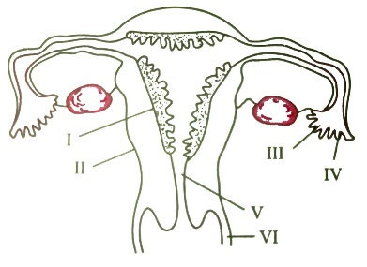

1. II – endometrium ; III – infundibulum ; IV – fimbrae
2. III – infundibulum ; IV – fimbrae ; V – cervix
3. IV – oviduct ; V – uterus ; VI – cervix
4. I – Perimetrium ; II – myometrium ; III – Fallopian tube
5. The secretory phase in the human menstrual cycle is also called :

|  |  |
| --- | --- |
| a) luteal phase and lasts for about 6 days | b) Follicular phase and last for about 6 days |
| c) luteal phase and lasts for about 13 days | d) Follicular phase and last for about 13 days |

1. Menstrual flow occurs due to lack of :

|  |  |  |  |
| --- | --- | --- | --- |
| a) FSH | b) oxytocin | c) vasopressin | d) progesterone |

1. The main function of mammalian corpus luteum is to produce :

|  |  |  |  |
| --- | --- | --- | --- |
| a) estrogen | b) progesterone | c) HCG | d) relaxin |

1. Atretic follicle are found in the :

|  |  |  |  |
| --- | --- | --- | --- |
| a) fallopian tubes | b) uterus | c) labia majora | d) ovary |

1. Which of the following events is not associated with ovulation in human female?

|  |  |
| --- | --- |
| a) LH surge | b) Decrease in estradiol |
| c) Full development of graffian follicle | d) release of secondary oocyte |

1. Which of the following layer in an antral follicle is acellular?

|  |  |  |  |
| --- | --- | --- | --- |
| a) Zona pellucida | b) granulosa | c) theca interna | d) stroma |

1. Identify the incorrect statement on inhibin?
2. is produced by granulosa cells in ovary and inhibits the secretion of FSH.
3. is produced by granulosa cells in ovary and inhibits the secretion of LH
4. is produced by nurse cells in testis and inhibits the secretion of LH
5. inhibits the secretion of LH , FSH and prolactin
6. Colostrum, the yellowish fluid secreted by mother during the initial days of lactation is very essential to impart immunity to the new born infants because it contains:

|  |  |  |  |
| --- | --- | --- | --- |
| a) immunoglobulin A | b) natural killer cells | c) monocytes | d) macrophages |

1. Which of the following is not a part of the female external genitilia?

|  |  |  |  |
| --- | --- | --- | --- |
| a) clitoris | b) Vagina | c) labia minora | d) labia majora |

1. A sac shaped like an upside down pear with a thick lining an muscles in pelvis area where a fertilized egg or zygote comes to grow into a baby is called _______

|  |  |  |  |
| --- | --- | --- | --- |
| a) Oviduct | b) uterus | c) vagina | d) vulva |

HUMAN REPRODUCTION Page No. 10

1. Which of the following is a finger like structure that lies at the upper junction of the two labia minora above urethral opening :

|  |  |  |  |
| --- | --- | --- | --- |
| a) Clitoris | b) Oviduct | c) Ampulla | d) Chorionic villi |

1. Bartholin’s gland occurs in :
2. Females, and helps in vestibular lubrication
3. Females, and produce estrogen for regulating secondary sexual characters.
4. Males and form liquid part of spermatic fluid.
5. Males and produce alkaline fluid for neutralizing urethral activity.
6. Which of the following best represents the normal path of a sperm cell as it make its way from the point of entry into the female’s reproductive tract to the place where fertilization typically occurs?

|  |  |
| --- | --- |
| a) Cervix , vagina , ovary and oviduct | b) vagina , cervix , uterus and oviduct |
| c) uterus, cervix , vagina and oviduct | d) vagina , uterus , cervix and oviduct |

1. Most of the primary follicles in the ovary normally:

|  |  |
| --- | --- |
| a) undergo atresia and disintegrate | b) Mature are ovulated. |
| c) are lost in the menstrual flow each month | d) Develop throughout the life span |

1. 10 Oogonia yield 10 primary oocytes, then how many ova are produced on completion of oogenesis?

|  |  |  |  |
| --- | --- | --- | --- |
| a) 5 | b) 10 | c) 20 | d) 40 |

1. In an oocyte, second maturation divisions occurs in :

|  |  |  |  |
| --- | --- | --- | --- |
| a) Ovary | b) abdominal cavity | c) fallopian tube | d) uterus |

1. Which of the following stage of oogenesis forms a membrane called zona pellucida surrounding it?

|  |  |  |  |
| --- | --- | --- | --- |
| a) Oogonia | b) Polar body | c) corpus luteum | d) Secondary oocyte |

1. Ovulation or release of ovum occurs on which day of the menstrual cycle?

|  |  |
| --- | --- |
| a) 8 – 10 | b) 12 – 14 |
| c) 4 – 14 | d) last 2 days of menstrual cycle |

1. Oocyte is liberated from ovary under the influence of LH after completing :
2. Mitosis and before liberating polar bodies
3. Meiosis I and before liberating second polar bodies
4. Meiosis
5. Meiosis II after release of first polar body
6. Onset of menstruation is due to :

|  |  |
| --- | --- |
| a) increase in level of progesterone | b) fall in the level of progesterone |
| c) increase in level of FSH | d) None of the above |

1. Menstruation result in the discharge of :

|  |  |
| --- | --- |
| a) the corpus luteum of the uterus | b) surface cells from the vagina |
| c) blood form the outer surface of the uterus | d) the endometrial lining |

1. Which of the following statement is correct ?

|  |  |
| --- | --- |
| a) Menstrual cycle is present in all mammals. | b) Menstrual cycle is present in all primates. |
| c) Estrous cycle occurs in all mammals | d) Most mammals are ovoviviparous |

HUMAN REPRODUCTION Page No. 11

1. In human female, menopause is a stage in which :
2. Oogenesis start at puberty.
3. Menstruation starts at puberty.
4. Corpus luteum starts secreting progesterone for maintaining pregnancy.
5. Menstruation stops at the age of 50 years and reproductive capacity is arrested.
6. Shortest phase in the menstruation cycle of women is :

|  |  |  |  |
| --- | --- | --- | --- |
| a) Menses | b) Luteal phase | c) Ovulatory phase | d) Follicular phase |

1. Which one of the following is not a phase of the menstrual cycle?

|  |  |  |  |
| --- | --- | --- | --- |
| a) Estrous phase | b) Luteal phase | c) Follicular phase | d) Menstrual phase |

1. Level of which hormones are at their highest during the luteal phase of the menstrual cycle?

|  |  |  |  |
| --- | --- | --- | --- |
| a) Estrogen | b) Progesterone | c) LH | d) FSH |

1. For approximately how long during the human’s female menstrual cycle are progesterone concentration high enough to maintain the uterus in a proper condition for pregnancy?

|  |  |
| --- | --- |
| a) All of the cycle | b) None of the cycle |
| c) During the first half of the cycle | d) During the second half of the cycle |

1. Which of the following hormone attain a peak level in the middle of menstrual cycle?

|  |  |
| --- | --- |
| a) LH and progesterone | b) FSH and progesterone |
| c) FSH and LH | d) Estrogen and progesterone |

1. Select the correct sequence of menstrual cycle.

|  |  |
| --- | --- |
| a) Menstruation , secretory , follicular , New cycle | b) Menstruation , follicular , luteal , New cycle |
| c) Follicular , Menstruation , Luteal , New cycle | d) Luteal , menstruation , follicular , New cycle |

1. Menstrual cycle is controlled by :

|  |  |
| --- | --- |
| a) LH and FSH only | b) estrogen , LH and FSH only |
| c) Estrogen and progesterone only | d) FSH , LH , Estrogen and progesterone |

1. Which of the following contains a fluid filled cavity called antrum.

|  |  |
| --- | --- |
| a) Primary spermatocyte | b) Primary follicle of ovary |
| c) Tertiary follicle of ovary | d) Secondary spermatocyte |

1. How many ova are released during the middle of the menstrual cycle?

|  |  |  |  |
| --- | --- | --- | --- |
| a) 1 | b) 2 | c) 3 | d) 4 |

1. ‘A’ cell starts division and enter in ‘B’ stage of meiotic division and get temporary ‘C’ at this stage, called ‘D’. Identify A, B, C and D.
2. A – Oogonia ; B – Metaphase I ; C – Arrested ; D – Primary oocyte.
3. A – Oogonia ; B – Anaphase I ; C – Released ; D – Secondary oocyte
4. A – Oogonia ; B – Prophase I ; C – Arrested ; D – Primary oocyte
5. A – Oogonia ; B – Telophase I ; C – Released ; D – Secondary oocyte
6. If you needed to take a blood sample during the time in a woman’s menstrual cycle when the concentration of her gonadotropic hormones would be at their lowest levels, which of the following days on an average would be the best choices for sampling?

|  |  |  |  |
| --- | --- | --- | --- |
| a) 1 to 5 | b) 5 to 10 | c) 10 to 15 | d) 20 to 25 |

HUMAN REPRODUCTION Page No. 12

1. Menstruation is initiated by :
2. A sudden release of FSH from the anterior pituitary
3. A lack of estrogen and progesterone due to degeneration of the corpus luteum.
4. An increased release of estrogen and progesterone from the corpus luteum.
5. A sudden drop in LH.
6. The given figure shows the diagrammatic sectional view of female reproductive system with few structures marked as A , B , C , D , E and F.

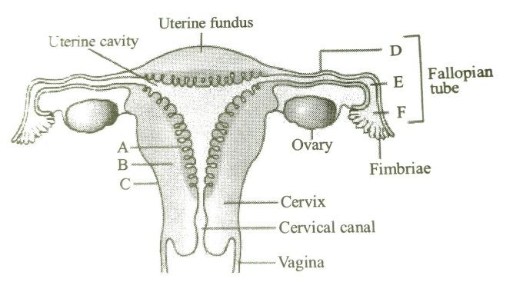

1. A – Myometrium ; B – isthmus ; C – Endometrium ; D – Perimetrium ; E – Ampulla ; F – Infundibulum
2. A – Infundibulum ; B – Perimetrium ; C – Endometrium ; D – Myometrium ; E – Ampulla ; F – Isthmus
3. A – Endometrium ; B – Myometrium ; C – Perimetrium ; D – Isthmus ; E – Ampulla ; F – Infundibulum
4. A – Perimetrium ; B – Endometrium; C – Isthmus ; D – Infundibulum ; E – Ampulla ; F – Myometrium
5. The given figure shows the diagrammatic representation of oogenesis. Identify the option which shows the correct labels for A , B , C and D

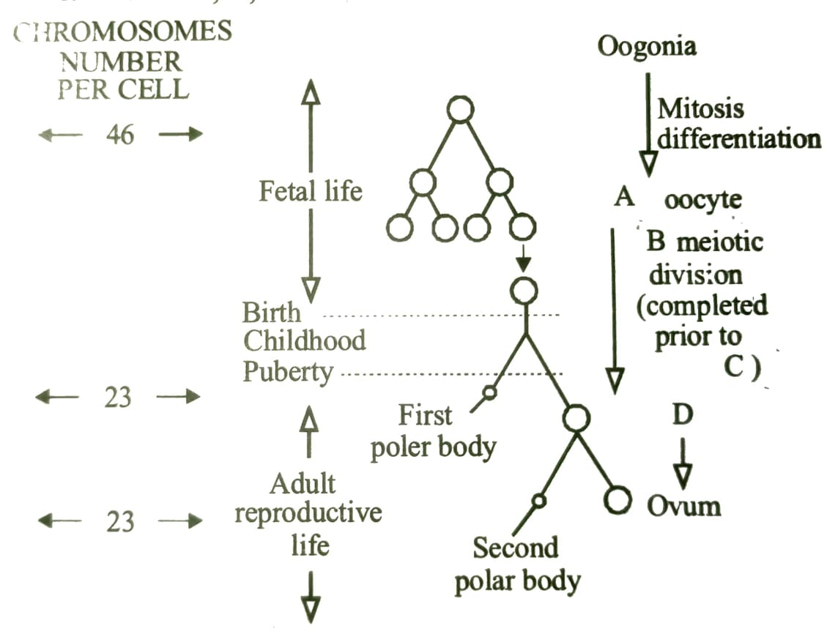

1. A – Tertiary ; B – I ; C – Fertilization ; D – Primary oocyte
2. A – Primary ; B – II ; C – Ovulation ; D – Secondary oocyte
3. A – Secondary ; B – II ; C – Fertilization ; D – Primary oocyte
4. A – Primary ; B – I ; C – Ovulation ; D – Secondary oocyte

HUMAN REPRODUCTION Page No. 13

1. Assume 2n = 12, in a hypothetical species. In gametogenesis, the number of chromosome in a spermatid would be _____ and in a first polar body would be ______.

|  |  |  |  |
| --- | --- | --- | --- |
| a) 3 , 6 | b) 3 , 3 | c) 6 , 3 | d) 6 , 6 |

1. Which of the following is an indicator of normal reproductive phase and extends between menarche and menopause?

|  |  |  |  |
| --- | --- | --- | --- |
| a) Ovulation | b) Implantation | c) Menstrual cycle | d) Estrous cycle |

1. Follicular atresia are :

|  |  |
| --- | --- |
| a) Formation of corpus luteum | b) Degeneration of follicles |
| c) Formation of graffian follicle | d) Increase in the number of follicles |

1. Antrum is the cavity of :

|  |  |  |  |
| --- | --- | --- | --- |
| a) Ovary | b) Blastula | c) gastrula | d) Graffian follicle |

1. The figure given below shows the various events occurring during a menstrual cycle with few marked as A , B , C , D and E. Which of the following options shows the correct labelling?

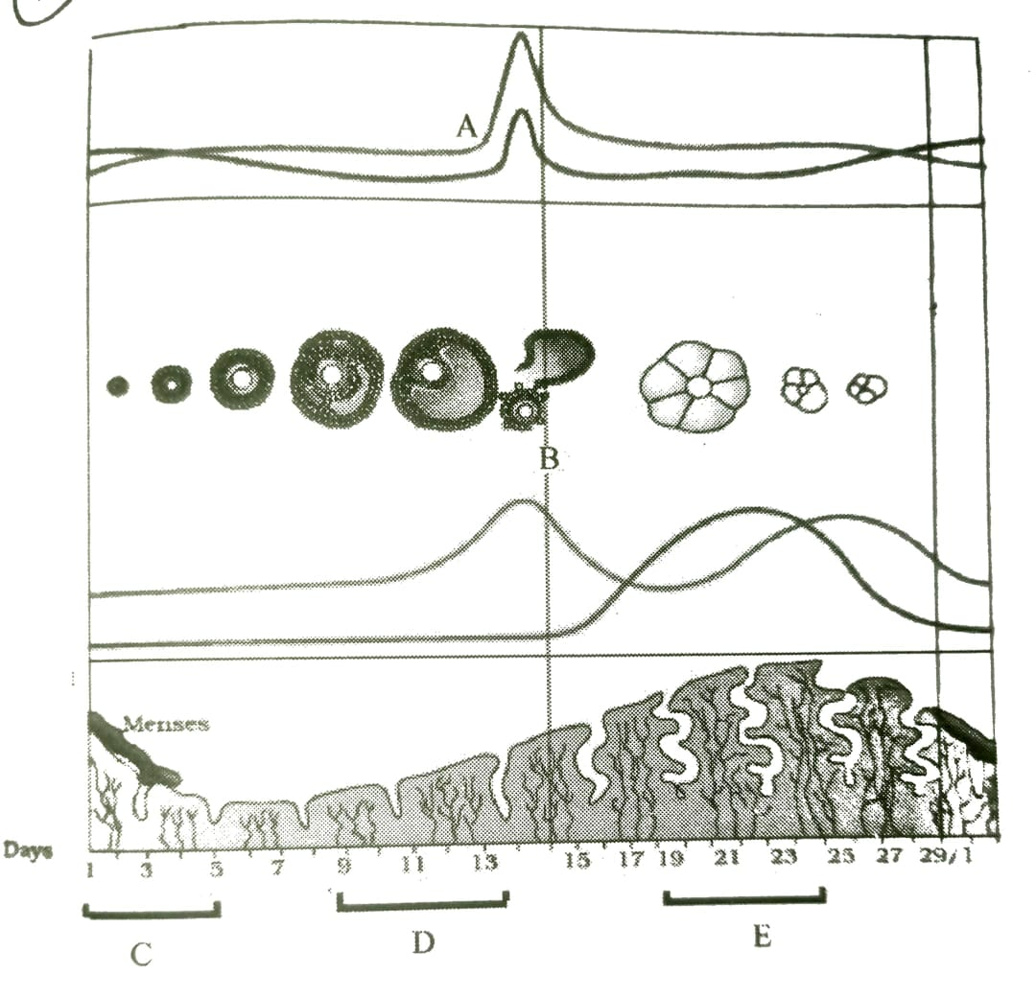

1. A – LH ; B – Ovulation ; C – Menstruation ; D – Proliferative phase ; E – luteal phase
2. A – FSH ; B – implantation ; C – Follicular phase ; D – Menstruation phase ; E – luteal phase
3. A – Estrogen ; B – Parturition ; C – Luteal phase ; D – follicular phase ; E – follicular phase
4. A – Progesterone ; B – Fertilization ; C – Menstruation ; D – Secretory phase ; E – follicular phase

HUMAN REPRODUCTION Page No. 14

1. The figure given below shows the sectional view of ovary. Select the option which gives correct identification of marked structure (A to D) and its feature.

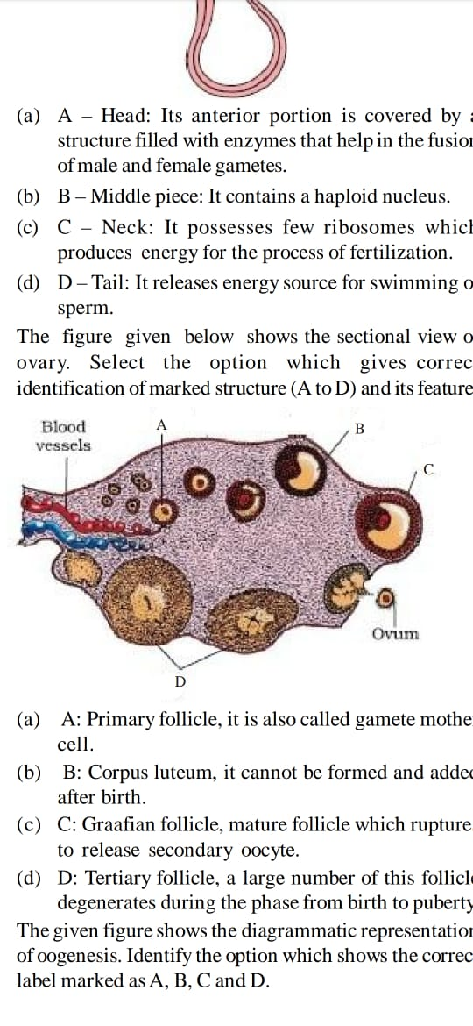

1. A : Primary follicle, it is also called gamete mother cell
2. B : Corpus luteum, it cannot be formed and added after birth
3. C: Graffian follicle, mature follicle which ruptures to release secondary oocyte.
4. D : Tertiary follicle, a large number of this follicle degenerates during the phase from birth to puberty.
5. The following graph of relative concentrations of the four hormones present in the blood plasma of a woman during her menstrual cycle. Identify the hormones.

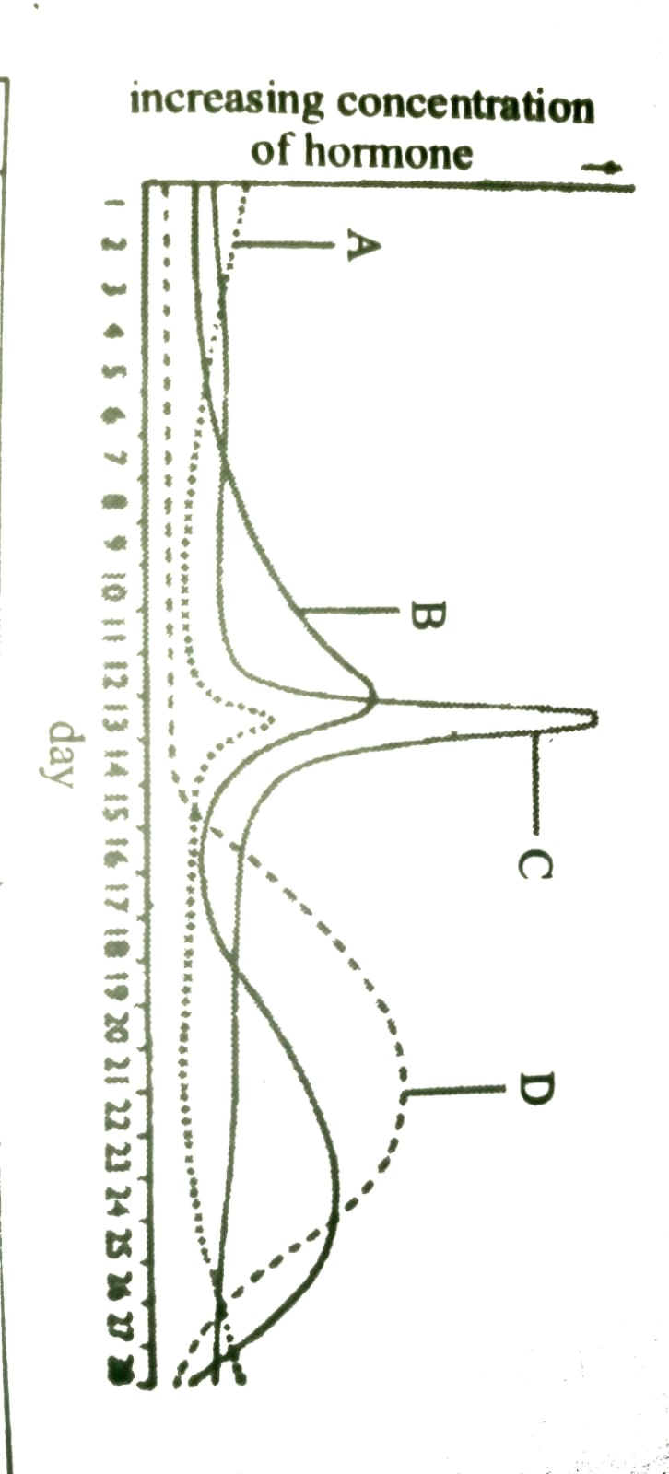

|  |  |  |  |  |
| --- | --- | --- | --- | --- |
|  | A | B | C | D |
| (a) | FSH | Progesterone | LH | Estrogen |
| (b) | LH | Progesterone | FSH | Estrogen |
| (c) | FSH | Estrogen | LH | Progesterone |
| (d) | LH | Estrogen | FSH | Progesterone |

1. Match column I and column II

|  |  |  |
| --- | --- | --- |
| Column I | Column II | |
| A. Proliferative phase | I. Testosterone | |
| B. Leydig cell | II. estrogen | |
| C. Spermiogenesis | III. Progesterone | |
| D. Secretory phase | IV. Spermatid | |
| a) A – II ; B – I ; C – IV ; D – III | | | b) A – IV ; B – II ; C – III ; D – I | |
| c) A – IV ; B – III ; C – II ; D – I | | | d) A – IV ; B – III ; C – I ; D – II | |

HUMAN REPRODUCTION Page No. 15

1. Read the following statements and answer the following question:
2. This structure is also called womb.
3. Its shape is like an inverted pear.
4. The process of fertilization takes place in this structure
5. The wall of this structure has three layers of tissue.
6. It secretes several steroid hormones.

Identify the correct characteristics feature regarding uterus from above statements.

|  |  |  |  |
| --- | --- | --- | --- |
| a) (i) , (iv) | b) (iii) & (v) | c) (i) , (ii) & (iv) | d) All are correct |

1. Which of the following statement regarding at the time reproductive system is (are) correct?
2. Myometrium undergoes strong contraction at the time of delivery of baby
3. Ovary is secondary female sex organ which produces female gamete and steroid hormones.
4. Ovarian stroma is divided into two zones : inner cortex and outer medulla
5. Infundibulum possess finger-like projections which help in collection of ovum after the release of secondary oocyte.
6. A functioning mammary gland is the characteristics of all the mammals (including male and female)

|  |  |  |  |
| --- | --- | --- | --- |
| a) (i) , (iv) | b) (i) , (ii) , (iii) & (v) | c) (iii) , (iv) & (v) | d) All are correct |

1. Match column I and column II

|  |  |  |
| --- | --- | --- |
| Column I | Column II | |
| A. Ampulla | I. It undergoes cyclic changes during menstrual cycle | |
| B. labia majora | II. It helps in collection of ovum after ovulation | |
| C. Oviduct | III. Wider part of fallopian tube where fertilization occur | |
| D. Fimbriae  E. Endometrium | IV. Larger hairy folds which extend down from the mons  pubis and surrounds the vaginal opening  V. Also called fallopian tube | |
| a) A – I ; B – II ; C – III ; D – V ; E – IV | | | b) A – III ; B – I ; C – II ; D – V ; E – IV | |
| c) A – III ; B – IV ; C – V ; D – II ; E – I | | | d) A – II ; B – IV ; C – III ; D – V ; E – I | |

1. Which of the following statements regarding mammary gland is incorrect?
2. They are paired glandular structures that lie over the pectoral muscles
3. Each gland has 100 – 150 lobulated , milk glands, each having a number of lobules containing number of alveoli.
4. The cells of alveoli secrete milk which is stored in the cavity of the alveoli.
5. Each milk gland has lactiferous ducts that drain into openings in the nipple
6. Which of the following is an example of positive feedback control in the reproductive cycle of females?
7. The increased response of the hypothalamus and anterior pituitary gland in response to estrogen
8. The decreased response of the hypothalamus and anterior pituitary gland in response to estrogen
9. The inhibition of LH by high levels of testosterone
10. The stimulation of LH by low levels of testosterone.

HUMAN REPRODUCTION Page No. 16

1. Milk secreted from the cells of alveoli of mammary lobes reaches nipple through lactiferous duct (L), mammary duct (M) , mammary tubule (T) and mammary ampulla (A) in the following order:

|  |  |  |  |
| --- | --- | --- | --- |
| a) TMAL | b) MTLA | c) MTAL | d) ATML |

1. Select the option which correctly matches the endocrine gland with its hormone and function.

|  |  |  |  |
| --- | --- | --- | --- |
|  | Endocrine gland | Hormone | Function |
| (a) | Ovary | FSH | Stimulate follicular development and the secretion of  estrogen |
| (b) | Placenta | Estrogen | Initiates secretion of the milk. |
| (c) | Corpus luteum | Estrogen | Essential for maintenance of endometrium |
| (d) | Leydig cells | Androgen | Initiation of cells for production of sperms |

1. Select the correct statements regarding oogenesis.
2. It is initiated during the embryonic development stage when millions of Oogonia are formed with in each ovary.
3. Graffian follicle releases primary oocyte from the ovary by ovulation.
4. At puberty, only 60,000 – 80,000 primary follicles are left in each ovary
5. Secondary oocyte with in tertiary follicle grows in size and completes its second maturation division.

|  |  |  |  |
| --- | --- | --- | --- |
| a) (i), (ii) and (iii) | b) (i) and (iii) | c) (ii) and (iv) | d) all are correct |

1. Match column I and column II

|  |  |  |  |
| --- | --- | --- | --- |
| Column I | Column II | | |
| A. Primary oocyte | I. It is formed when oogonium starts division and temporarily  arrested at prophase of meiosis I | | |
| B. Secondary oocyte | II. A large haploid cell which retains bulk of nutrient rich cytoplasm  of the primary oocyte | | |
| C. Primary follicle | III. A large number of these degenerate during the phase form  puberty to birth | | |
| D. Oogonia  E. Secondary follicle  F. Graffian follicle | IV. Gametes mother cell  V. Surrounds by more layers of granulosa cells and a new theca  VI. Ruptures to release ovum from the ovary | | |
| a) A – I ; B – II ; C – III ; D – IV ; E – V ; F – VI | | | b) A – III ; B – I ; C – IV ; D – II ; E – V ; F – VI |
| c) A – VI ; B – IV ; C – V ; D – II ; E – I ; F – III | | | d) A – II ; B – IV ; C – III ; D – V ; E – I ; F – VI |

1. Match column I and column II

|  |  |  |  |
| --- | --- | --- | --- |
| Column I | Column II | | |
| A. Endometrium | I. Copulation chamber in female | | |
| B. Menopause | II. Site of implantation of zygote | | |
| C. Fallopian tube | III. Cessation of menstrual cycle in females | | |
| D. Vagina | IV. Site of fertilization in female | | |
| a) A – II ; B – III ; C – IV ; D – I | | | b) A – IV ; B – II ; C – III ; D – I |
| c) A – IV ; B – III ; C – II ; D – I | | | d) A – IV ; B – III ; C – I ; D – II |

HUMAN REPRODUCTION Page No. 17

1. Study the given statement and answer the following question:

During ‘P’ phase of the menstrual cycle, If pregnancy doesn’t happen, the ‘Q’ withers and dies, usually around day 22 in a 28 day cycle. The drop in ‘R’ levels causes the lining of the uterus to fall away. This is known as ‘S’. Identify P , Q , R and S.

1. P – Menstrual ; Q – Graffian follicle ; R – estrogen ; S – Menarche
2. P – Luteal ; Q – Corpus luteum ; R – Progesterone ; S - Menstruation
3. P – Ovulatory ; Q – Endometrium ; R – FSH ; S - Menopause
4. P – Follicular ; Q – Secondary oocyte ; R – LH ; S - Menstruation

**Answers**

|  |  |  |  |  |  |  |  |
| --- | --- | --- | --- | --- | --- | --- | --- |
| 1. a | 1. c | 1. a | 1. b | 1. a | 1. b | 1. a | 1. d |
| 1. b | 1. d | 1. a | 1. d | 1. c | 1. a | 1. a | 1. c |
| 1. c | 1. b | 1. a | 1. d | 1. b | 1. c | 1. d | 1. b |
| 1. d | 1. b | 1. a | 1. a | 1. a | 1. b | 1. b | 1. a |
| 1. a | 1. b | 1. a | 1. b | 1. c | 1. d | 1. b | 1. b |
| 1. b | 1. d | 1. b | 1. d | 1. c | 1. a | 1. b | 1. d |
| 1. c | 1. b | 1. d | 1. c | 1. a | 1. c | 1. d | 1. b |
| 1. c | 1. d | 1. d | 1. c | 1. b | 1. d | 1. a | 1. c |
| 1. c | 1. a | 1. c | 1. a | 1. c | 1. b | 1. a | 1. a |
| 1. d | 1. b | 1. a | 1. a | 1. b |  |  |  |
|  |  |  |  |  |  |

HUMAN REPRODUCTION Page No. 18

|  |
| --- |
| **Neha Malhotra** **R.L. Chemistry Classes M: 9253556635**  **Class : XII**  **“HUMAN REPRODUCTION”** |

**Level – 3**

**(Based on Fertilization and Post-fertilization events)**

1. The human embryo with 8 to 16 blastomere is called :

|  |  |  |  |
| --- | --- | --- | --- |
| a) Morula | b) Blastula | c) Gastrula | d) Foetus |

1. At the time of fertilization, sperm head enters in the egg from :

|  |  |  |  |
| --- | --- | --- | --- |
| a) Anywhere | b) Animal pole | c) vegetal pole | d) lateral side of egg |

1. Which of the following is the precise site of embryo implantation in a normal pregnancy?

|  |  |  |  |
| --- | --- | --- | --- |
| a) Endometrium | b) vagina | c) oviduct | d) cervix |

1. Sperm produces an enzymatic substance for dissolving egg coverings. It is called :

|  |  |  |  |
| --- | --- | --- | --- |
| a) Hyaluronic acid | b) Hyaluronidase | c) Androgamone | d) Diastase |

1. In human females meiosis II is not completed until :

|  |  |  |  |
| --- | --- | --- | --- |
| a) Fertilization | b) Implantation | c) Birth | d) Puberty |

1. Which chemical of the eggs attract and hold sperm?

|  |  |  |  |
| --- | --- | --- | --- |
| a) Fertilizin | b) Anti-fertilizin | c) Agglution | d) Anti-agglutin |

1. Part of sperm involved in penetrating egg membrane is :

|  |  |  |  |
| --- | --- | --- | --- |
| a) Tail | b) acrosome | c) allosome | d) autosome |

1. Fertilization occurs in :

|  |  |  |  |
| --- | --- | --- | --- |
| a) Uterus | b) Ureter | c) Vagina | d) fallopian tube |

1. At the time of implantation, the human embryo is called :

|  |  |  |  |
| --- | --- | --- | --- |
| a) Zygote | b) Blastocyst | c) Embryo | d) Foetus |

1. Which of the following is the first change that occur to the zygote after fertilization?
2. It divides to form a hollow ball of cells, called the blastocyst.
3. It begins to secrete the hormones.
4. It contact the endometrial walls of the uterus and becomes buried inside it.
5. It initiated the formation of placenta.
6. Fertilization is depicted by the condition :

|  |  |  |  |
| --- | --- | --- | --- |
| a) n $→$ 2n | b) 2n $→$ 4n | c) 2n $→$ 4n | d) 4n $→$ 8n |

1. Gestation period is the duration between :

|  |  |
| --- | --- |
| a) Ovulation and fertilization | b) Maturation of egg and ovulation |
| c) Implantation and parturition | d) Ovulation and Parturition |

1. During forth moth of pregnancy, the progesterone is secreted by :

|  |  |  |  |
| --- | --- | --- | --- |
| a) Placenta | b) Corpus luteum | c) Corpus albicans | d) Uterus |

HUMAN REPRODUCTION Page No. 19

1. Structure connecting the foetus to placenta is :

|  |  |  |  |
| --- | --- | --- | --- |
| a) Umbilical cord | b) Amnion | c) Chorion | d) Yolk sac |

1. The milk ejection reflex is stimulated by :

|  |  |  |  |
| --- | --- | --- | --- |
| a) Estrogen | b) Oxytocin | c) Prolactin | d) Progesterone |

1. Amnion is helpful to embryo in :

|  |  |  |  |
| --- | --- | --- | --- |
| a) Nutrition | b) Protection from shock | c) Excretion | d) Respiration |

1. The longest gestation period is found in :

|  |  |  |  |
| --- | --- | --- | --- |
| a) Elephant | b) Gorilla | c) Chimpanzee | d) Man |

1. Vitellogenesis is the process of formation of :
2. Vitelline membrane around the developing egg cells.
3. Yolk sac membrane around the yolk mass during the development of reptiles and birds.
4. Yolk and its deposition within the growing oocyte of amphibians.
5. Change of vitelline membrane into fertilization membrane.
6. Fixing up of blastocyst in the wall of uterus is called :

|  |  |  |  |
| --- | --- | --- | --- |
| a) Impregnation | b) Placentation | c) Implantation | d) Fertilization |

1. Which of the serve as embryonic urinary bladder?

|  |  |  |  |
| --- | --- | --- | --- |
| a) Amnion | b) Chorion | c) Allantois | d) Yolk sac |

1. Oxygenated blood flowing in umbilical cord of mammalian embryo is :

|  |  |
| --- | --- |
| a) 50 % maternal and 50 % foetal | b) 100 % maternal |
| c) 100 % foetal | d) 70 % maternal and 25 % foetal |

1. Development in all multicellular animals happens in which of the following sequence?
2. Gastrula $→$ Blastula $→$ Cleavage $→$ Germ layers formation.
3. Cleavage $→$ Gastrula $→$ Blastula $→$ Germ layers formation.
4. Cleavage $→$ Blastula $→$ Gastrula $→$ Formation of primary Germ layers.
5. Formation of primary Germ layers $→$ Cleavage $→$ Blastula $→$ Gastrula.
6. Delivery of foetus is scientifically called as :

|  |  |  |  |
| --- | --- | --- | --- |
| a) Parturition | b) Oviposition | c) abortion | d) Ovulation |

1. The extra structure that provides nutrition to the embryo is :

|  |  |  |  |
| --- | --- | --- | --- |
| a) Umbilicus | b) Amnion | c) Chorion | d) Placenta |

1. Which of the following organ is differentiated first during development?

|  |  |  |  |
| --- | --- | --- | --- |
| a) Heart | b) Skin | c) Brain | d) Neural tube |

1. The sex of foetus will be decided at :

|  |  |
| --- | --- |
| a) Fertilization by male gamete | b) Implantation |
| c) Fertilization by female gamete | d) The start of cleavage |

1. Which of the following induces parturition?

|  |  |  |  |
| --- | --- | --- | --- |
| a) Vasopressin | b) Oxytocin | c) GH | d) TSH |

1. Which of the following differentiate into an embryo?

|  |  |  |  |
| --- | --- | --- | --- |
| a) Morula | b) Zygote | c) Trophoblast | d) Inner cell mass |

HUMAN REPRODUCTION Page No. 20

1. Which layer of blastocyst gets attached to the endometrium?

|  |  |  |  |
| --- | --- | --- | --- |
| a) Trophoblast | b) Inner cell mass | c) Umbilical cord | d) Both (a) and (c) |

1. The placenta is formed from _______ of the embryo and the _______ of the mother.

|  |  |
| --- | --- |
| a) Uterus , Trophoblast | b) Chorion , Endometrium |
| c) Endometrium , Chorion | d) Inner cell mass , Endometrium |

1. Primary germ layers are :

|  |  |
| --- | --- |
| a) Inner cell mass and Ectoderm only | b) Trophoblast , Ectoderm and Mesoderm |
| c) Endoderm and Mesoderm only | d) Ectoderm , Endoderm and Mesoderm |

1. _________ is the sticky white or yellow fluid secreted by the breasts during the second half of pregnancy and for few days after birth.

|  |  |  |  |
| --- | --- | --- | --- |
| a) Placenta | b) Colostrum | c) Egg yolk | d) Blood cells |

1. By the end of how many weeks major organ system are during the embryonic development?

|  |  |  |  |
| --- | --- | --- | --- |
| a) 4 weeks | b) 8 weeks | c) 12 weeks | d) 24 weeks |

1. Which of the following induces foetal ejection reflex?

|  |  |
| --- | --- |
| a) Initiation of lactation | b) Fully developed foetus and placenta |
| c) Expulsion of the baby out of the uterus | d) Transport of embryo in the fallopian tube. |

1. During embryonic development, the heart begins at the end of :

|  |  |  |  |
| --- | --- | --- | --- |
| a) 1st trimester | b) 2nd trimester | c) 1st month | d) 2nd month |

1. Cleavage in the fertilized egg of humans :

|  |  |
| --- | --- |
| a) Starts in uterus. | b) Is meroblastic |
| c) Starts when egg is in fallopian tube. | d) Is discoid |

1. Gery crescent is the area :
2. At the point of entry of sperms into ovum.
3. Just opposite to the site of entry of sperm into ovum.
4. At the animal pole.
5. At the vegetal pole.
6. Which extra-embryonic membrane in humans prevents desiccation of the embryo inside the uterus?

|  |  |  |  |
| --- | --- | --- | --- |
| a) Chorion | b) allantois | c) yolk sac | d) amnion |

1. The role of the corpus luteum and the hormones it produces ends :
2. At the time of embryonic implantation in the uterus.
3. With the formation of the placenta.
4. During the second trimester of pregnancy.
5. Just prior to parturition.
6. The majority of human organs formation occurs :
7. Entirely during the last trimester of pregnancy.
8. After implantation and during first trimester of pregnancy.
9. Shortly before the onset of true labour.
10. Due to the stimulation generated during Braxton hicks contractions.

HUMAN REPRODUCTION Page No. 21

1. An important factor contributing to the onset and maintenance of labour contractions is :
2. Increase contractility of the uterine muscles from increased oxytocin levels.
3. Mechanical pressure on the cervix generated by the emerging baby’s head.
4. Stretching of the uterus during the final stages of foetal growth.
5. All of the above.
6. Identical twins result when:
7. The zygote divides and the daughter cells split and developed independently.
8. Two eggs with identical genetic material are fertilized, each by a different sperm.
9. An embryo splits before cellular differentiation has occurred.
10. Both (a) and (c)
11. Study the following statements and answers the following questions :

In a process called ‘A’, ‘B’ division starts as the zygote moves through the ‘C’ of the ‘D’ towards the ‘E’.

1. A – Blastula ; B – Meiotic division ; C – Ampulla ; D – Fallopian tube ; E – Uterus
2. A – Parturition ; B – Meiotic division ; C – Infundibulum ; D – Uterus ; E – Vagina
3. A – Implantation ; B – Mitotic division ; C – Fimbriae ; D – Ovary ; E – Cervix
4. A – Cleavage ; B – Mitotic division ; C – Isthmus ; D – Fallopian tube ; E – Uterus
5. Match column I and column II

|  |  |  |
| --- | --- | --- |
| Column I | Column II | |
| A. Hyaluronidase | I. Graafian follicle | |
| B. Corpus luteum | II. Mammary gland | |
| C. Colostrum | III. Progesterone | |
| D. Antrum | IV. Acrosomal reaction | |
| a) A – II ; B – I ; C – IV ; D – III | | | b) A – IV ; B – II ; C – III ; D – I | |
| c) A – IV ; B – III ; C – II ; D – I | | | d) A – IV ; B – III ; C – I ; D – II | |

1. Hormones secreted by human placenta during early stage of pregnancy are :

(i) Human chorionic gonadotrophin (ii) Human placental lactogens (iii) Relaxin

(iv) Progesterone and estrogen

|  |  |
| --- | --- |
| a) (i) and (ii) | b) (i) , (ii) , (iii) and (iv) |
| c) (iii) and (iv) | d) (i) , (ii) and (iii) |

1. Match column I and column II

|  |  |  |
| --- | --- | --- |
| Column I | Column II | |
| A. Fertilization | I. Mitotic division | |
| B. Implantation | II. Embryo with 8 to 16 blastomeres | |
| C. Cleavage | III. Ampulla | |
| D. Morula | IV. Structure formed by continuous division of 8 to 16 blastomeres. | |
| E. Blastocyst | V. Embedding of blastocyst in the endometrium | |
| a) A – I ; B – II ; C – IV ; D – V ; E – III | | | b) A – III ; B – I ; C – IV ; D – II ; E – V | |
| c) A – III ; B – V ; C – I ; D – IV ; E – II | | | d) A – III ; B – V ; C – I ; D – II ; E – IV | |

HUMAN REPRODUCTION Page No. 22

1. Match column I and column II

|  |  |  |
| --- | --- | --- |
| Column I | Column II | |
| A. Parturition | I. During between pregnancy and birth | |
| B. Ovulation | II. Embedding of blastocyst in the endometrium | |
| C. Gestation | III. Childbirth | |
| D. Implantation | IV. Stoppage of menstruation | |
| E. Conception | V. Release of egg from mature graafian follicle  VI. Process of mil secretion.  VII. Formation of zygote | |
| a) A – I ; B – II ; C – VII ; D – V ; E – III | | | b) A – III ; B – I ; C – IV ; D – II ; E – V | |
| c) A – III ; B – V ; C – I ; D – II ; E – VII | | | d) A – III ; B – V ; C – I ; D – IV ; E – II | |

1. Study the statement given below and answer the question.

“Vigorous contraction of the ‘X’ at the end of the ‘Y’ causes expulsion of the foetus. Identify ‘X’ and ‘Y’.

|  |  |
| --- | --- |
| a) X = Vagina ; Y = Fertilization | b) X = Uterus ; Y = Pregnancy |
| c) X = Placenta ; Y = Implantation | d) X = Embryo ; Y = Ovulation |

1. Which of the following statements about the mammalian blastocyst is not correct?

|  |  |
| --- | --- |
| a) The trophoblast give rise to the embryo proper. | b) Maternal genes are expressed during cleavage. |
| c) Th blastocyst implants in mother’s uterus. | d) Early mammalian development is slow. |

1. Consider the following statements and identify correct option regarding Umbilical cord.
2. Umbilical cord contains blood vessels from embryo.
3. Umbilical cord joins the placenta and the embryo.
4. Umbilical cord carries waste and nutrients.
5. Umbilical cord contains blood vessels from mother.

|  |  |
| --- | --- |
| a) All are correct | b) All are incorrect |
| c) Only (iv) is incorrect | d) Only (i) is correct |

1. Second polar body is produced during the formation of :

|  |  |  |  |
| --- | --- | --- | --- |
| a) sperm | b) ovum | c) secondary oocyte | d) spermatocytes |

1. Which of the following statements about human pregnancy and foetal development is incorrect?
2. The blastocyst is a stage in foetal development that appears early during the third trimester.
3. A vital connection between the foetal and maternal blood supplies occurs at the placenta.
4. Most of the growth in foetal size occurs during the 2nd and 3rd trimester.
5. All major organs systems have formed by the end of the 1st trimester.
6. Which of the following statements about parturition is incorrect?
7. Prolactin induces uterine contraction.
8. It is induced by neuroendocrine mechanism.
9. Uterine contraction leads to expulsion of baby through the birth canal.
10. Oxytocin plays and important role in the contractions of fallopian tube.
11. Extrusion of second polar body from egg nucleus occur :

|  |  |
| --- | --- |
| a) After entry of sperm but before fertilization | b) After fertilization |
| c) Before entry of sperm into ovum | d) Simultaneously with first cleavage |

HUMAN REPRODUCTION Page No. 23

1. The amnion of mammalian embryo is derived from :

|  |  |
| --- | --- |
| a) Ectoderm and mesoderm | b) Endoderm and mesoderm |
| c) Ectoderm and endoderm | d) Mesoderm and trophoblast |

1. Which of the following is not an important component of initiation of parturition in humans?
2. Synthesis of prostaglandins.
3. Release of oxytocin.
4. Release of prolactin.
5. Increase in estrogen and progesterone ratio.
6. Which of the following is not the function of placenta?
7. secretes estrogen.
8. Facilitates removal of CO2 and waste material from embryo.
9. Secrets oxytocin during parturition.
10. Facilitates supply of O2 and nutrients to embryo
11. In a normal pregnant women, the amount of total gonadotrophin activity was assessed. the result expected was :
12. High level of circulating FSH and LH in the uterus to stimulate implantation.
13. High level of HCG to stimulate endometrial thickening.
14. High level of circulating FSH and LH in the uterus to stimulate endometrial thickening.
15. High level of HCG to stimulate estrogen and progesterone synthesis.
16. The first movement of the foetus and appearance of hairs on its head are usually observed during _______ moth of pregnancy.

|  |  |  |  |
| --- | --- | --- | --- |
| a) 4th month | b) 5th month | c) 6th month | d) 3rd month |

1. Which of the following statements about morula in human is correct?
2. It has almost equal quantity of cytoplasm as an uncleaved zygote but much more DNA.
3. It has far less cytoplasm as well as DNA than in an uncleaved zygote.
4. It has more or less quantity of cytoplasm and DNA as in uncleaved zygote.
5. It has more cytoplasm and more DNA as in uncleaved zygote
6. In the given figure the structure of ovum is surrounded by few sperms and some parts labelled as A , B , C and D. Select the correct labelling.
7. A – Zona pellucida ; B – Ovum ; C – Cells of corona radiata ; D – Perivitelline space.
8. A – Perivitelline space ; B – Antrum ; C – Zona pellucida ; D – Ovum.
9. A – Zona pellucida ; B – Ootid ; C – Cells of corona radiata ; D – Perivitelline space.
10. A – Cells of corona radiata ; B – Morula ; C – Perivitelline space ; D – Zona pellucida.
11. Which of the following human development stage becomes embedded in the uterine endometrium by a process called implantation and leads to pregnancy?

|  |  |  |  |
| --- | --- | --- | --- |
| a) | b) | c) | d) |

1. The given figure shows human foetal development. Select the correct labelling.
2. A – Umbilical cord with its veins ; B – Chorionic villi ; C – Antrum ; D – Plug of mucus in cervix.
3. A – Umbilical cord with its vessels ; B – Fimbriae ; C – Oocyte ; D – Plug of mucus in vagina.
4. A – Umbilical cord with its vessels ; B – Placental villi ; C – Yolk sac ; D – Plug of mucus in cervix.
5. A – Umbilical cord with its veins ; B – Placental villi ; C – Trophoblast ; D – Plug of mucus in vagina.
6. Where does fertilization of egg occur in the female reproductive tract?

|  |  |  |  |
| --- | --- | --- | --- |
| a) | b) | c) | d) |

1. Which of the following undergoes cyclic changes during different phases of menstrual cycle?

|  |  |  |  |
| --- | --- | --- | --- |
| a) oviducts | b) vagina | c) uterus | d) external genitalia |

1. The number of chromosomes in a mature gamete gets halved during :

|  |  |
| --- | --- |
| a) | b) |
| c) | d) |

Which one of the following events is correctly matched with the time period in a normal menstrual cycle